Bricknell Primary School

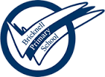

Art and Design Policy

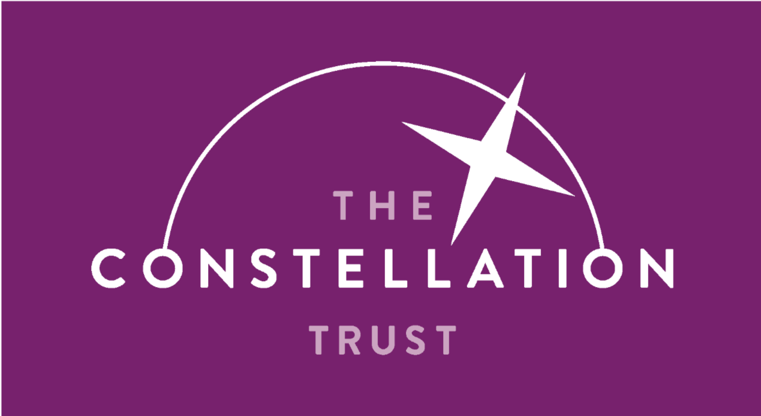

Art and Design Policy
Subject Co-ordinator: Matt Mullen

Curriculum Intent
Art and design embodies some of the highest forms of human creativity which engages, inspires and challenges pupils, equipping them with the knowledge and skills to experiment, invent and create their own works of art, craft and design. By teaching Art and design, we intend to impart pupils with the knowledge, understanding, confidence, attitudes, values and skills they need in order to reach their potential as individual artists.

At Bricknell Primary School, the teaching of Art and design curriculum has been carefully considered to enable our pupils to become confident and competent artists and designers. At Bricknell, we follow a program that has been written by the subject co-ordinator and curriculum leader in collaboration with secondary art specialists from the Constellation Trust. Our highly skilled subject leader has carefully worked to create a Curriculum Overview Document where objectives for each year group are progressively mapped out to ensure our pupils are given the acquired skills and knowledge the further their education journey into KS3 and life beyond the classroom.

Our aim is to provide inclusive and aspirational environments and learning experiences where pupils thrive and build the cultural capital they need to make aspirational choices about their own futures, overcoming any barriers. In order to achieve this, our curriculum is underpinned by the principles highlighted in our Aspiration Curriculum.
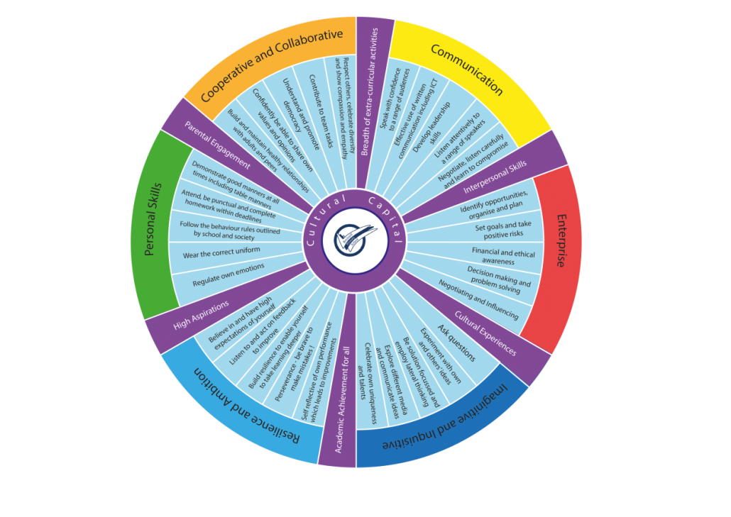

Within the Art and design Curriculum Overview Document, our progressive objectives identify what pupils should know by the end of each year group and link to prior learning. These enable teachers to identify and plug gaps in pupil’s knowledge and skills. Within Art and design, pupils will develop a deep understanding of key concepts and second order concepts. These key concepts have been carefully considered and identified as the core knowledge and skills required to successfully achieve in Art and design. The Key concepts are revisited and developed as the pupils move through the school to ensure the knowledge and skills are firmly embed within the long term memory. These key concepts compliment work carried out across the school in line with Aspiration Curriculum. The expectation is that, by the end of Primary School, children will know and understand these key concepts and have the knowledge and skills to enter KS3 Art and design curriculum.

In addition to first order concepts, the subject leader has identified subject specific second order concepts. These can be used across all aspects of a subject to organise the substantive knowledge and skills taught.

Key concepts:
Pupils theoretical knowledge will be developed through the study of artists and designers, looking at the history of art and how artists have expressed ideas using different materials and processes. As they move through the school, they will build their practical knowledge through the making skills of drawing, painting and mixed media, developing ideas through sketchbooks and applying their knowledge to their artwork. Pupils’ disciplinary knowledge will be developed by studying the work of traditional, modern and contemporary artists, evaluating and commenting on what is valid and of quality.

Knowledge of artists and designers

Pupils will develop an understanding of the history of art. They will study how different artists have applied the component knowledge of different materials and processes to communicate ideas and how this has changed over time. Pupils will learn about significant artists, pieces of art work and artistic movements.

Exploring and developing ideas

Pupils will use their developing knowledge of art to explore their ideas in different ways, including through sketchbooks; becoming more confident in experimenting, creating and refining their work. They will learn to demonstrate fluency, experimentation and authenticity in the art they learn about and produce
- Fluency: Pupils learn to recall the component knowledge and to become more proficient in a range of methods and techniques
- Experimentation: Pupils develop the knowledge of methods, materials and processes to be able to try out ideas and make informed choices
- Authenticity: Pupils develop secure knowledge in the making skills below and learn how to use these to communicate their ideas through art

Making skills: Drawing, painting, mixed media and 3D


Pupils will learn the practical knowledge they need and learn how to apply this to their own work with increasing proficiency. By building their knowledge of drawing, painting and a wider range of media including sculpture, they will learn about and apply a range of practical knowledge to different projects.

They will develop their knowledge of
- Methods and techniques, such as shading, printing or collage
- Media and materials, including pencil, pen, paper, wire, clay and paint
- Formal elements of line, tone, shape, colour, form, pattern and texture
(See table overleaf)

Evaluating

Pupils will look at the work of artists as examples of experts at work, including art from different times and in different forms. They will learn to understand art as a discipline so they can answer questions such as, ‘What is art?’ ‘What counts as art?’ ‘What makes an artist?’ by developing an understanding of what is valid and of quality. They will learn how to evaluate and appreciate how different artists have represented ideas in different ways through different media or periods in art eg: looking at how different artists have represented the same theme in different ways.

A Summary of the component knowledge for the making skills
Practical –Domains of Knowledge |  |  |  |  | Formal elements of art and design
Specialisms | Media and materials |  | Methods and techniques |  | Visual tools that the artist uses to create a composition
Drawing | Graphite Pen (2b, 4b, 6b, 2h)  Eraser  Coloured pencils  Brush & Ink  Charcoal, Chalk  Oil Pastel  Soft Pastel  Crayon |  | Line quality, Mark Making, hatching, cross hatching, scribble, stippling, blending, shading, sketching, enlarging, reducing, collage, primary and secondary observational drawing, layering, gridding, view finder, primary and secondary observation, blind drawing |  | Line | A line is the path left by a moving point
 |  |  |  |  | Shape | A shape is an area enclosed by a line
Painting | Watercolour (pan & tube)  Acrylic Gouache, Tempera,  Oils | Papers Brushes Palette knife Rollers Sponges | Under painting, blocking in, wet on wet, building up, dry brushing, s’graffito, washes, underpainting, glazing, stippling, dabbing, palette, wax resist |  | Form | Form is a 3D shape such as a sphere, cube or cone
 |  |  |  |  | Tone | Tone means the lightness and darkness of something
 |  |  |  |  | Colour | Three primary colours: Red, blue and yellow. By mixing two primary colours you get secondary colour: orange, green and purple
Sculpture | Clay  Card & cardboard  Plaster  Wax  Wood  Textiles |  | Modelling, carving, fixing or joining materials such as card, metals and plastics, using processes such as soldering, brazing, welding, gluing, |  | Texture | Texture is the surface quality of something, the way something feels or looks like it feels
 |  |  |  |  | Pattern | A pattern is the design that is created by repeating other formal elements eg: line, shape, colours

Second Order Concepts:
Second order concepts are fundamental knowledge and skills which are transferable across a range of curriculum subjects. For example, we introduce pupils to the concept of ‘similarity and difference’ early in their education, developing the observational skills and language needed to make comparisons. This is developed and applied as pupils move through the school so they can confidently apply this in all areas of the curriculum by upper Key Stage Two.
A summary of the second order concepts and how they apply to Art & Design are provided in the table below.

Curriculum subject | Significance | Similarity and difference | Cause and consequence | Continuity and change | Responsibility | Communication (Oracy & Written) | Enquiry
Art | Significant artists, works of art and art movements. | Comparing works of art and artistic styles. Identifying common features and different approaches |  | How art has changed over time |  | Using artistic terminology, evaluating, creative expression, giving opinions, presenting | Visits to galleries, exhibitions, sculptures etc… Investigating art in different places and contexts

In Art and design, by the end of EYFS children will:
- Be able to use art to be creative and express themselves in different ways
- Be able to create pictures of what they can see and imagine
- Develop some control when using pencils, paint brushes and other materials

They will know that art conveys both thinking (ideas) and feeling (emotion). They will use a variety of ways to express and communicate through art. They will know that creative thinking involves original responses, not just copying or imitating existing artworks. They will use their imagination, curiosity, creativity, cognition, critical thinking and experimentation skills to allow them to improvise, collaborate, interact and engage in artistic sustained shared thinking. They will have time, space and opportunity to revisit and reflect on artistic experiences. Children in EYFS will safely use and explore a variety of materials, tools and techniques, experimenting with colour, design, texture, form and function. They will share their creations, explaining the process they have used. They will make use of props and materials when role playing characters in narratives and stories.

By the end of Key Stage 1 children will:
- Be able to use a range of materials in a creative way to design and make products
- Be able to use drawing, painting and sculpture to develop and share their ideas, experiences and imagination.
- Develop their own use of colour, pattern, texture, line, shape, form and space.
- Know about the work of a range of artists, craft makers and designers, describe similarities and differences between different practices and principles, and used some of their techniques in their own work.

By the end of Key Stage 2 children will:
- Develop their techniques to create and experiment with greater control and choice of materials through the study of great artists and designers.
- Be confident in the use of sketch books to record their observations, develop review and refine their ideas.
- Have improved their mastery of a range of art and design techniques including drawing, painting and sculpture with a range of materials.
- Be aware of different kinds of art, craft and design and the techniques that are used to create them.

Implementation
At Bricknell Primary School, our curriculum is carefully mapped out into a Long-Term Plan by our highly skilled subject coordinator. This enables links between subjects to be identified and carefully planned for to support pupil’s retention of knowledge and skills.

Art is taught using the Kapow scheme of work. It offers full coverage of the Key Stage 1 and Key Stage 2 curriculum as well as incorporating SMSC development. The content is categorised into 5 areas: Making Skills, Generating Ideas, Formal Elements, Knowledge of Artists and Evaluating. Each unit contains lessons which are designed to be taught in sequential order, with the exception of the lessons in Making Skills and Formal Elements units which can be taught in any order. These 2 units feature within each of the year groups and develop the discrete skills and techniques of art, craft and design. Work is planned with reference to the National Curriculum and the Constellation Trust progressive knowledge document. The National Curriculum breaks Art down into 4 strands; Materials, Techniques, Artists and Expression and Imagination. Skills in the EYFS are planned through the objectives within the EYFS Statutory Framework and ensure progression into Key Stage 1.

Our scheme of work has been designed as a spiral curriculum with the following key principles in mind: cyclical (pupils return to the same skills again and again during their time in Bricknell Primary School), increasing depth (each time a skill is revisited it is covered with greater complexity, prior knowledge (upon returning to a skill, prior knowledge is utilised so pupils can build upon previous foundations).

Formal elements of art units are taught (with the exception of Year 6) and these lessons focus on the discrete skills of the formal elements of art: line, shape, tone, texture, pattern, colour. Each year group from Year 1 to Year 6 has a unit called Art and Design Skills which focusses specifically on developing pupils’ art, craft and design skills in a discrete way. The application of skills from these two recurring units are then applied throughout the rest of the scheme (eg sculpture and collage, pre historic art, etc).

At Bricknell, all Art and design lessons will follow the same teaching sequence outlined below.

Revisit prior learning

Appraise work of artists as inspiration using the formal elements
Assess pupil’s understandig and progress assessment spreadsheet

Learn and develop making skills based on formal elements
Share and evaluate work with peers against formal elements

Develop ideas for a final composition

Create a final composition

Impact
A wide range of strategies are used to measure the impact of our Art and design curriculum. In EYFS, staff professional judgements are valued. Assessments are formative so that they quickly make a difference to children’s learning. They inform the provision of activities and experiences which develop children’s skills and knowledge as well as giving opportunity for further practise. We record WOW moments on Tapestry and build up a detailed picture of each child using a Child on a Page document.
Our teaching sequence allows children from KS1-2 to respond to a ‘Big Question’ and to assess how they feel they achieved in each session. The impact of our Art and design curriculum is also monitored daily across the school in a variety of different environments across structured and unstructured times.

Assessments are also carried out at the end of each lesson against the learning objective. They are all listed at the start of a teaching unit in a block starter. This is placed in the pupils’ books and is assessed as either ‘partially met’ or ‘fully met’. If the objective is ‘partially met’ or not met at all, an intervention takes place at the start of the following lesson. During the lesson, pupils’ misconceptions or gaps in subject knowledge are addressed and opportunity is given for further practice. At the end of the unit, the pupils evaluate their own work against the formal elements. Pupils also reflect on whether they feel their artistic intentions have been met in the piece or artwork that they have produced. At Bricknell, we offer a variety of additional support for children who are working below age related expectations with Art and design.

Our Subject Leader will also monitor the effectiveness of the Art and design curriculum through carrying out regular subject 360 evaluations. These evaluations are quality assured by the Senior Leadership and Governors.

The effectiveness of Art and design is also monitored through pupil and parental voice throughout the course of the year.

Extra-curricular
Artists from the local community are welcomed into our school to be a part of developing themes and helping children to have a wide range of exposure to different skills. An after school art club runs each week in Key Stage 1 and Key Stage 2. There is also a lunchtime KS2 artclub that meets for an hour every week.

Cross curricular connections
The art skills learnt are used across the curriculum for example drawing diagrams in Science, illustrations and story maps to accompany writing and making repeating patterns in DT. Art and design therefore is evident across the school in a variety of different settings as well as in daily classroom practice. Art and design second order concepts are evident in subjects such as DT, Science, History and Geography. This is through developing the knowledge of chronology, similarities and differences, significance and expression. We believe these are key skills to learning and help prepare children for life at KS3 and beyond the classroom.

Equality
We believe that pupils at Bricknell Primary School should not be discriminated against in terms of the 9 protected characteristics (Age, Disability, Gender reassignment, Marriage/Civil partnership, Pregnancy/Maternity, Race, Religion/Belief, Sex and Sexual orientation). This intent is embedded and implemented across the whole PSHE curriculum. All children should have the opportunity to participate fully in classroom PSHE lessons, extra-curricular and whole school activities, therefore reasonable adjustments are made to accommodate all pupils.

SEND
At Bricknell, we have a high SEND population and our pupils are fully immersed into the broad and balanced curriculum. However, we tailor the curriculum to meet the individual needs of SEND pupils. Where a child’s need prevents them from accessing the Age Related Expectations for subjects, planning is tailored to meet the individual needs of all pupils using CPTs(curriculum progression toolkit). This document breaks down each objective across the curriculum to enable all pupils to achieve success at an appropriate level for their needs. The CPTs enable pupils to address any gaps in learning. In addition to this, some pupils are given the opportunity to take part in an AQA life skills programme. This programme consists of a sequence of skills that children work towards and develop their independence. This programme has been developed by the external agency IPASS and is tailored to meet the individual needs of our pupils. Each skill, when mastered, is rewarded with a qualification and certificate.

Metacognition
Metacognition relates to thinking about thinking. It is a mechanism to enhance student learning, both for immediate outcomes and for helping students to understand their own learning processes. Metacognitive strategies are embedded into all areas of our curriculum and opportunities are planned to develop these skills over time. These skills include self-questioning, meditation, reflection, developing an awareness of strengths and weaknesses and an awareness of personal learning styles. Developing this metacognitive understanding is a skill for life. When learners “think about their thinking” they are more capable of independent self-improvement. At Bricknell, metacognitive strategies are learned, practiced and made into habits in order to improve learning, self-understanding and thinking skills impacting both the present and future.

Our metacognition and working memory model is shown below:

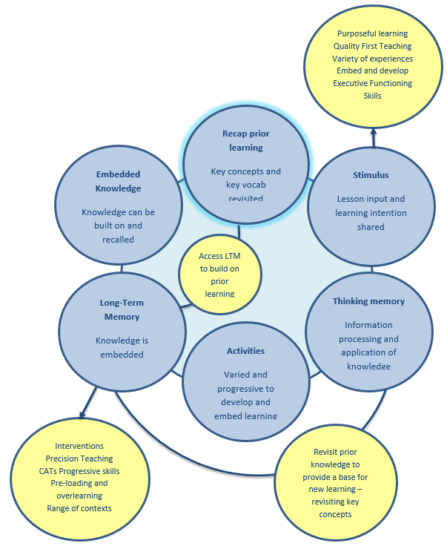

All staff have had extensive CPD, in collaboration with the Educational Psychologist, to support their understanding of child development and metacognition strategies to enable them to develop the knowledge and skills required to enable children to learn progressively over time.

Evaluation
In evaluating the effectiveness of our teaching of Art, we should be aware of the following:
- Do we allow children to express creative and original thinking through Art?
- Do we provide children with opportunities to work with a variety of tools, materials, techniques and mediums?
- Do we provide children with regular opportunities to develop their creative skills?
- Do we give children access to a variety of Art of different genres and styles, including Art from different cultures?
- Do we allow children to express their feelings and opinions about Art?

Resources
A range of personalised resources has been created by our highly skilled subject leader for each year group. In addition, links to websites, artwork and videos have been signposted in the Medium Term Plans and supporting resources.

Staff CPD
At Bricknell Primary School, invest heavily in CPD to ensure all staff feel empowered to deliver lessons, across all curriculum subjects, and have the ability to embed and assess the metacognition strengths of all pupils.

